

***We will aspire to great things, shine our light and reach our God given potential.***

*‘let your light shine.’ (Matthew 5:16)*

Email: [school@be.jmat.org.uk](mailto:school@be.jmat.org.uk)

Website: [www.bramptonellis.co.uk](http://www.bramptonellis.co.uk/)

Tel: 01709 760370

26th February 2025

Dear parent/carer

As you can see from the diagram below, being late has a big impact on your child’s education. Therefore, from Monday 3rd March 2025 if your child is late to school (KS2 8:50am/KS1 8.30am) please be advised that you are now required to come into the office, with your child/ren and explain the reason for their lateness. This is due to the fact that children don’t always know why they are late and we have a legal obligation to record accurate reasons. This will also allow us to support you in anyway we can.

Absences after 9:20am (KS2) and 9.10am (KS1) will be marked as a ‘U’ (unauthorised) mark on registers. The authority may decide to pursue a fixed penalty notice if these occur regularly.

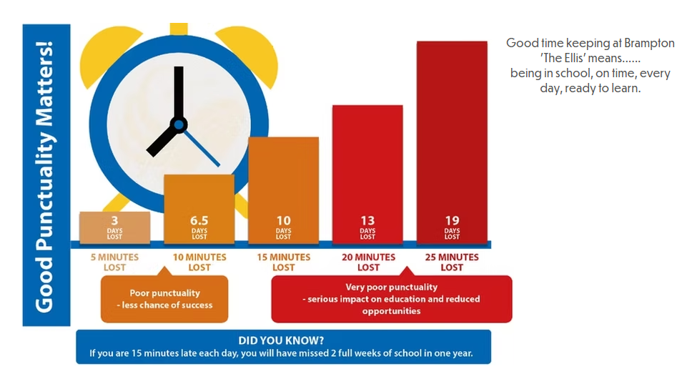

Yours sincerely,

Mr Adam Minor

Head Teacher