tia

***We will aspire to great things, shine our light and reach our God given potential.***

*‘let your light shine.’ (Matthew 5:16)*

Email: [school@be.jmat.org.uk](mailto:school@be.jmat.org.uk)

Website: [www.bramptonellis.co.uk](http://www.bramptonellis.co.uk/)

Tel: 01709 760370

28th February 2025

**Collective Worship**

This week in collective worship we have be thinking about the ‘fruits of the spirit’ in Galantian’s (the 9th book of the New Testament written by St Paul the Apostle). The fruits of the spirit are: love, joy, peace, patience, kindness, goodness, faithfulness, gentleness and self-control. We thought abut how these are good characteristics to have and how they are similar to our school values and motto of ‘let your light shine’.

**Parents Evenings**

Don’t forget it parents’ evenings next week. At KS2 we will leave the small gate on Regency Road open, as the front door won’t be accessible. If you haven’t made an appointment, please do so, or contact your child’s parent to arrange an alternative day/time.

**World Book Day**

Don’t forget it’s also World Book Day next week. I’ve got my costume ready, which is linked to a book. I’m really looking forward to hearing all about your favourite books.

**Late Letter**

Please check your emails for a message entitled ‘Information Regarding Punctuality’. This letter explains our new procedure for checking your child into school if they arrive late. The main point in the letter is that you must now accompany your child into school and explain a reason for their lateness. This will take effect from Monday 3rd March.

**Important Dates**

|  |  |  |
| --- | --- | --- |
| **W/C 3rd March** | **W/C 10th March** | **W/C 17th March** |
| **4th & 5th Parents Evenings**  **5th – Curlew Class Assembly@9am**  **6th _ World Book Day** | **12th – Y2 Trip to Conisbrough Castle**  **13th – Class Photos** | **17th – Viking Talk @ Y4**  **18th Y3 Visit to Tropical World & Nightingale trip Emergency Museum**  **18th Easter Service Y?? @ church 9am**  **21st House of Cedar Event** |

**Letters sent out this week-**

1. **Skylark Cleethorpes**
2. **Y6 Gulliver’s**
3. **Measles, Chicken Pox and Shingles**
4. **Letter for late children**

**Messy Breakfast and Pancake Party events**

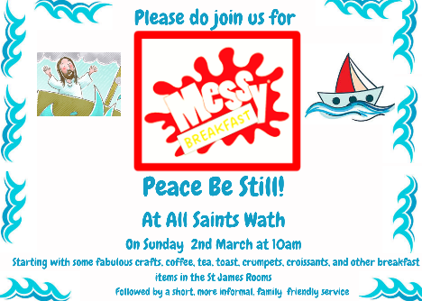

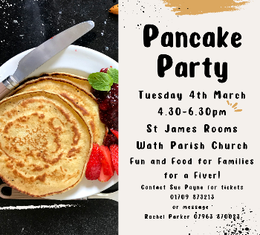

**Special Mentions**

|  |  |  |  |
| --- | --- | --- | --- |
| **Year** | **Learning Award** | **Value Award** | **Reading Award** |
| **F2** | **Kingfishers-** Romeo, for taking responsibility pf his own learning and making better choices during continuous provision time | **Kingfishers-** Lilly-Mae, for super writing about her half term. Lilly-Mae used her tricky word and graphene mats to help her! | **Kingfishers-** Isabella, for super segmenting and blending of words! |
| **Y1** | **Skylarks-** Grayson - Learner - for showing interest in learning and sharing the facts that he knows. | **Skylarks-** Lily-Jean - Value - for being kind, caring and respectful to her friends. | **Skylarks-** Theodore - Reading - for making big improvement in reading and applying all of the skills he has. |
| **Y1/2** | **Nightingale-**  Mia J (Y2) for a fantastic attitude towards all learning! Mia is always happy, positive and loves to learn. | **Nightingale-**  Elliott W (Y2) for being a responsible member of Nightingales. Elliott works really hard to ensure our classroom is a tidy, organised and safe place to learn. He's a fantastic helper! | **Nightingale-** Harper C (Y1) for being an amazing and passionate reader! I am so proud of the wonderful reader she has become. |
| **Y2** | **Puffins-** Evelyn for having the confidence to share ideas and thoughts to the class AND for great maths work. | **Puffins-** Cleo for fabulous, independent maths work on adding lengths. | **Puffins-** Julia for being a thoughtful reader with good comprehension skills. |
| **Y3** | **Swift-** Ben W-Working hard to produce a lovely piece of writing.  **Swallow-** Arlowe -learning -for her resilience in maths well done!  **Housemartins-** Ava - learning award for her work in maths and accessing chili challenge work | **Swift-** Antonina K-Always following the three R's and being a good role model to others.  **Swallow-** Willow- values- for always looking after everyone in the class and being kind to everyone, thank you  **Housemartins-** Eva - for increased responsibility for her learning and attitude in class | **Swift-** Ava G-becoming more confident in reading out loud during reading practice.  **Swallow-** Oliver- reading - having a fantastic attitude towards reading, very impressed  **Housemartins-** Cayman - reading champion for work in phonics and passing his latest assessment. |
| **Y4** | **Avocets-** Olivia B- Star Learner for her understanding and detailed answers in reading practice lessons  **Curlews-** Jan for always trying his best in every lesson and for always challenging himself and looking to improve his work.  **Oystercatchers-** Jack B- we were so proud of you leading actions and singing in assembly. | **Avocets-** Lacey S- Star value of Responsibility for her contribution to lessons and being supportive in partner work.  **Curlews-** Melissa for always following our school values and for being a great role model to the class.  **Oystercatchers-** Jack B - we were so proud of you leading actions and singing in assembly. | **Avocets-** April N- Reading Champion for her love of reading and confidence to read aloud in the class.  **Curlews-** Alfie for his great expression and confidence when reading aloud in reading practice.  **Oystercatchers-** Charlie L - being really resilient and developing your answers in reading. |
| **Y5** | **Kestrel-** Harper- for trying really hard to capture the tone of an informal letter in her writing this week!  **Merlin-** Hattie for her amazing contributions in English and carrying the class in completing our plans for our informal letter.  **Peregrines-** Sophie F for coming up with fantastic ideas for her writing | **Kestrel-** Lewis- for always following our school values and being kind and caring towards his peers.  **Merlin-** Ethan for respecting everyone in class and letting his light shine when helping others in the classroom.  **Peregrines-** Jenson H for always showing respect and being kind and polite | **Kestrel-**  Harry N- for increasing confidence in reading out loud, getting more involved in reading lessons and using the text well to answer questions  **Merlin-** Eryn and Polly for reading an extraordinary amount during the holidays and really diving into their love of reading.  **Peregrines-** Harriet B-S for taking on the responsibility of listening to others read and giving fantastic encouragement to others |
| **Y6** | **Kites-** Alex H - Learning award - some excellent descriptive devices and ideas in his writing this week.  **Eagles-** Isla- For challenging herself in writing to use descriptive devices and even completing some of her story at home.  **Sparrowhawks-**Ava S- Star Learner - for always producing high quality, excellent work. | **Kites-** Liam - Values award - for taking responsibility over his own learning and organising himself ready for task.  **Eagles-** Amrit- For always demonstrating resilience when editing and improving her work.  **Sparrowhawks-** Jackson E- Star Value - for taking great responsibility for his own learning and pushing himself further. | **Kites-** Alex K - Reading award - for being able to talk about his favourite author.  **Eagles-** Eliana- For beautiful reading during our reading for pleasure.  **Sparrowhawks-** Henry S- Reading Champion - for being such an enthusiastic reader and wanting to read the class books. |

**Attendance**

|  |  |  |  |
| --- | --- | --- | --- |
| **Class** | **Weekly Attendance Figure** | | |
| **F2 - Kingfisher** | **90%** | | |
| **F2/Y1 – Skylark** | **96.25%** | | |
| **Y1/Y2 - Nightingale** | **94.29%** | | |
| **Y2 – Puffin** | **99.66%** | | |
| **Y3** | **House Martin** | **Swift** | **Swallow** |
| **92.61%** | **92.22%** | **98.75%** |
| **Y4** | **Avocet** | **Oystercatcher** | **Curlew** |
| **87.93%** | **93.2%** | **95.86%** |
| **Y5** | **Merlin** | **Kestrel** | **Peregrine** |
| **90.71%** | **95%** | **100%** |
| **Y6** | **Sparrowhawk** | **Eagle** | **Kite** |
| **96.52%** | **95.22%** | **90.83%** |

Have a lovely weekend.

Yours faithfully,

Mr Adam Minor