

***We will aspire to great things, shine our light and reach our God given potential.***

*‘let your light shine.’ (Matthew 5:16)*

Email: [school@be.jmat.org.uk](mailto:school@be.jmat.org.uk)

Website: [www.bramptonellis.co.uk](http://www.bramptonellis.co.uk/)

Tel: 01709 760370

17th January 2025

**Miss Smith (Kingfishers)**

Miss Smith will not be in school for the rest of this term: She is having some time off to have an operation and will need some time to recover. Miss Smith is well and is expected to make a full recovery. She is sad that she won’t be able to see the term out and will miss all of the children in her class. I am sure that you join us in wishing her a speedy recovery.

**Sponsored Walk, Books and Resources**

I just wanted to update you with how we have spent the money raised (£6,300) from the sponsored walk last term. We have been working hard to select quality texts to replace our KS2 reading scheme as well as quality resources for our KS1 classes.

We have spent £2,100 on fiction text for KS2 and £1,940 on non-fiction and poetry texts. There is a great selection available. These books will be available for children to use and borrow from next week. Please encourage your child/children to look after these and treat them with care. A letter has also gone home to explain how this will work.

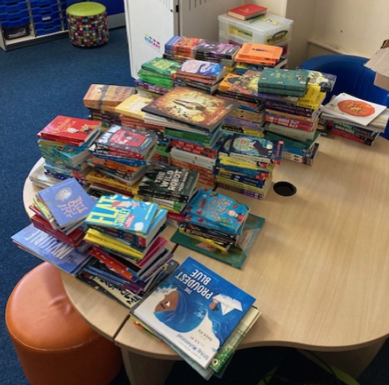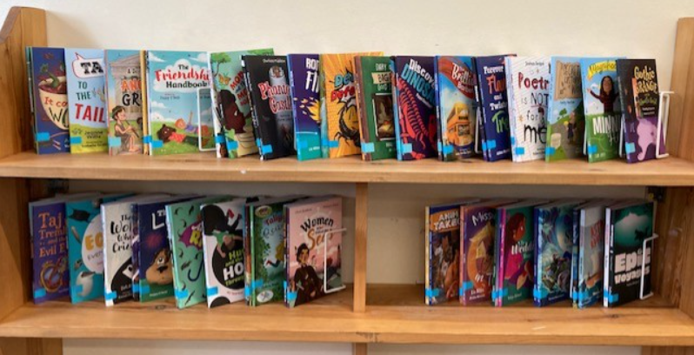

KS1 has spent £1,950 on resources to enhance classroom provision and learning through play. A selection of these resources are shown below.

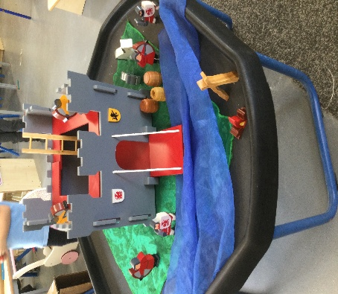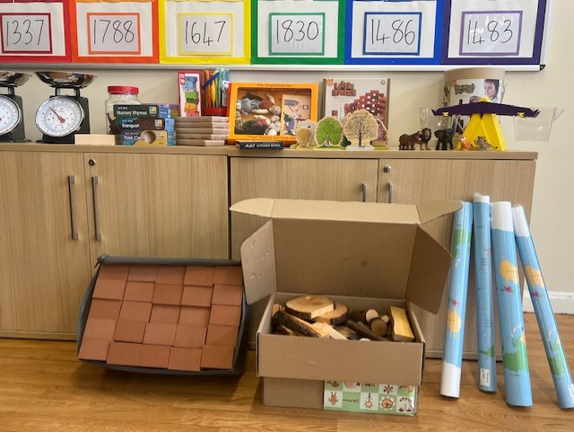

KS1 has also purchased blending books for F2 at a cost of £310

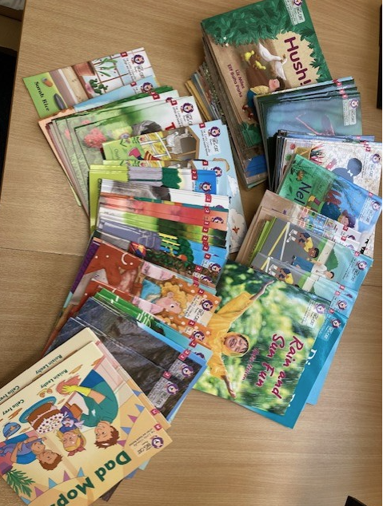

I would like to thank you all again for your generosity and fundraising efforts. The books and resources purchased will help to make a real difference and positive impact on our children. Considering we raised more than expected we have been able to fund a further £3,000 on Little Wandle phonics books for KS1 and Y3.

**INSET Days Next School Year (2025-26) and Holidays**

Next year we are planning to have the following INSET days:

* Monday 1st September 2025
* Thursday 21st May 2026 and Friday 22nd May 2026
* Friday 17th July 2026 and Monday 20th July 2026

May INSET days:

We are planning to put the three INSET dates the week before May half term to support families to book cheaper holidays. I appreciate that the cost of a family holiday in the school holidays is very expensive. We are also trying really hard to improve children’s attendance (to reduce missed learning) and would like to reduce the risk of families being fined for taking holidays in termtime. Therefore, if possible, please book your holiday during this time period.

I have chosen to tag the INESTs to May half term because the weather (at home and abroad) is better at that time of year and prices are significantly cheaper the week before half term. Below is an example of the saving you could make. Prices are based on a holiday through ‘On the Beach’.

Example 1 - based on 2 adults and 2 children

Manchester to Majorca (Sol Barbados)

7 nights

Half board

Thur 21st May 2026 – Wed 27th May 2026 - £2,433.02

Sat 23rd May 2026 – Sat 30th May 2026 - £2,838.02

Example 2 - based on 2 adults and 2 children

Manchester to Costa de Algarve, Portugal (Aquashow Park Hotel)

7 nights

Bed and breakfast

Thur 21st M ay 2026 – Wed 27th May 2026 - £3,863.65

Sat 23rd May 2026 – Sat 30th May 2026 - £4,533.28

As you can see going away at this time can be cheaper. Please book your holiday at this time if you can.

We have also followed Wath Academy’s Summer holiday dates and will break up on Thursday 16th July instead of Monday the 20th July. This means that there are also lots of bargains to be had if you book your holiday on Friday 17th July before most other schools break up.

**Important Dates**

|  |  |  |
| --- | --- | --- |
| W/C 20th January 2025 | W/C 27th January 2025 | W/C 3rd February 2025 |
| 23rd - Sparrowhawks Class Assembly @9am | 30th - Parents Working Party 9am@KS2 | 5th – Housemartin Class Assembly@9am |

**Special mentions**

|  |  |  |  |
| --- | --- | --- | --- |
| **Year** | **Learning Award** | **Value Award** | **Reading Award** |
| **F2** | **Kingfishers-** Abel, for working hard and being resilient with his writing and letter formation | **Kingfishers-** Tillie, when she is on the writing table she is always respectful and reminds others to correctly tidy pencils away. | **Kingfishers-**  Sophie, good independent reading |
| **Y1** | **Skylarks-** Florence - being independent and always ready for learning. | **Skylarks-** Sofia - for being resilient,  brave, confident and amazing. We are all so proud of you. | **Skylarks-** Jacob - for making progress and concentrating in his reading. |
| **Y1/2** | **Nightingale-** Oliver A (Y2) for always being responsible. Oliver loves tidying the reading corner, picking up any pencils and making sure all of the chairs are pushed in. Oliver makes sure that our classroom is a safe and tidy place to learn. | **Nightingale-** Freddie F (Y1) for fantastic writing this week! Freddie has worked really hard on his fact file and ensuring that he presents his work neatly. | **Nightingale-** Mark G (Y1) for showing enthusiasm for reading. Mark is always focused during phonics and reading practice. |
| **Y2** | **Puffins-**Elsie B, for amazing high quality writing! | **Puffins-** Charlie, for his resilience and determination in maths. He loves to be challenged! | **Puffins-** Audrey, for her enthusiasm for books and stories, and effort in comprehension |
| **Y3** | **Swift-** Alice W-Fantastic work in gymnastics.  **Swallow-** Oliver - Giving 110% in English, especially in his editing , well done!  **Housemartins-** Scarlett - for always giving learning 100% effort and tackling challenges in maths and english | **Swift-** Stanley H-Taking responsibility for his own behaviour.  **Swallow-** Kai - For helping Ms Law to settle into Swallows class and being kind and helpful.  **Housemartins-** Roman - for his resilience in lessons | **Swift-** George S-working hard to secure his phonics knowledge.  **Swallow-** Rosie- - Being enthusiastic about reading , well done!  **Housemartins-** Cayman - reading award for his work in phonics and his developing reading fluency |
| **Y4** | **Avocets-** Miah -for her hard work in doubling and halving in Maths  **Curlews-** Mason, for his resilience and dedication in every lesson. He has been trying very hard to work more independently and has been trying hard to use previous knowledge to support him in class - especially in Maths.  **Oystercatchers-** Freya - working hard to improve her learning in maths. | **Avocets-** Jacob S- for his interest in the Viking topic and his willingness to learn new things.  **Curlews-** Finley, for his resilience in Maths this week working out multi-step problems. Keep up the amazing work!  **Oystercatchers-** Decima - being really resilient with improving her maths. | **Avocets-** Freddie B and Callen - star readers - for their amazing attitude to reading and sharing books.  **Curlews-** Robin, for his incredible love of reading and always sharing recommendations with the class.  **Oystercatchers-** Theo M- always reading so expressively. |
| **Y5** | **Kestrel-** Leo- fantastic effort since coming back to school, working hard on his presentation but also the quality of his work!  **Merlin-** Olivia for smashing her chilli challenges in maths and going above and beyond in all subjects!  **Peregrines-** Amelia T for fantastic ideas and contributions in art | **Kestrel-** Esme- super resilience in Maths when adding and subtracting mixed numbers, an increase in confidence and sharing her ideas with the class.  **Merlin-**Poppy for her confidence and responsibility when showing the class the balances in gymnastics.  **Peregrines-** Edward H for always showing respect towards others and being a good friend | **Kestrel-** Freddie- listening carefully during reading and whizzing through retrieval questions!  **Merlin-** Kelsie for her brilliant book review on Harry Potter. She is a super fan and loved telling Mrs Bradwell all about her favourite Harry Potter books.  **Peregrines-** Poppy P for taking on extra reading and showing a fantastic attitude |
| **Y6** | **Kites-** Alex - for his attitude towards extra intervention and the progress he’s making  **Eagles-** Isabel- For listening to feedback and responding with resilience.  **Sparrowhawks-**  Rachel, - Star Learner - for listening carefully to constructive feedback and producing a fantastic diary entry. | **Kites-** Henry B- always showing our 3Rs particularly responsibility over his learning and wanting to improve  **Eagles-** Liam- For always showing a huge amount of resilience and doing so with a huge smile.  **Sparrowhawks-** Freddie N - for being a responsible partner and showing great resilience in his learning. | **Kites-** Callum L- for showing an enthusiasm towards reading in our booster sessions  **Eagles-** Elijah- For showing confidence when reading aloud in class.  **Sparrowhawks-** Holly P- Reading Champion - for making great progress in her understanding of the text. |

**Attendance**

|  |  |  |  |
| --- | --- | --- | --- |
| **Class** | **Weekly Attendance Figure** | | |
| **F2 - Kingfisher** | **87.69%** | | |
| **F2/Y1 – Skylark** | **90.4%** | | |
| **Y1/Y2 - Nightingale** | **90%** | | |
| **Y2 – Puffin** | **100%** | | |
| **Y3** | **House Martin** | **Swift** | **Swallow** |
| **94.78%** | **93.33%** | **97.08%** |
| **Y4** | **Avocet** | **Oystercatcher** | **Curlew** |
| **95.52%** | **98.75%** | **97.59%** |
| **Y5** | **Merlin** | **Kestrel** | **Peregrine** |
| **90.71%** | **98%** | **98.62%** |
| **Y6** | **Sparrowhawk** | **Eagle** | **Kite** |
| **93.91%** | **95.22%** | **92.5%** |

Have a lovely weekend.

Yours faithfully,

Mr Adam Minor